Asking Everyday Questions

Dear Parents,
There are many ways that you can assist your child in becoming the best reader possible. Some of these methods do not even involve books or stories, rather they involve thinking strategies that lead to reading discoveries. It is important to remember that reading is actually a thinking process. One in which we gather new or interesting information and make it a part of our lives. By helping your child think more about the world in which they live, you will be assisting in the development of strategies that foster reading development. Children who are encouraged to think and question their environment are children who develop good comprehension skills. You can stimulate your child’s thinking by asking questions for which there may be many possible answers. You and your child may want to use some of the following as examples.
- Why do we have lines painted on the street?
- Where does the wind go?
- How tall can trees grow?
- What do some animals do when it gets dark?
- Why do animals need to drink water?
- Why are there so many different colors?
Reading Tip of the Week: Punch a small hole in the top and bottom of several uncooked eggs and blow out the contents. Help your child draw the faces of some characters in a favorite book on each egg with crayons or markers. Your child can then use these “puppets” to act out a portion of the story for other family members. Encourage your child to set up a display in their room of the different characters they make.
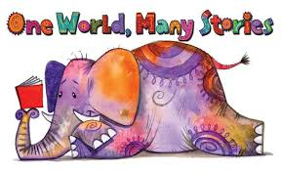
Sincerely,
Mrs. White

