Developing Good Comprehension

Dear Parents.
One of the major goals of reading instruction is to help children attain high levels of comprehension. Children who understand more of what they read are children who enjoy reading more. Parents can play a vital role in helping their children attain deeper comprehension skills.
Comprehension can occur naturally during your sharing time together, when you are reading a story to your child, or even when you are traveling in the car. Providing your child with opportunities to reflect and appreciate what they read can be an important contribution to their reading development.
- Before you and your child read a story together, ask your child to formulate a question about the title or initial illustrations. This helps your child develop a reason for reading the story.
- Some children enjoy making up their own questions about a story after it is read. You may wish to encourage your child to develop their own questions they would ask someone about the story, and then discuss the answers.
- It is often a good idea to keep a vocabulary notebook, or write words on index cards when reading stories with your child. This provides an opportunity for your child to record any new words, which can be defined and written in his or her own sentences.
- As you and your child are reading a story together, stop every so often and ask your child to draw a picture of a significant event. After completing the story, ask your child to arrange the pictures in the correct order that they happened in the story.
- After you have finished reading a story, ask your child to summarize it in as few words as possible. Help your child come up with a statement that conveys the main idea of the entire story.
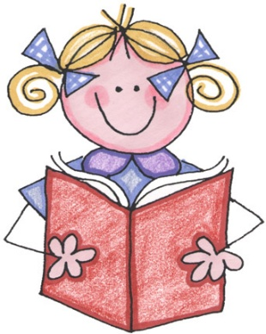
Reading Tip of the Week: Write your child lots of notes and leave them in various places around the house (refrigerator, front door, bathroom) One idea is to write your child a new note each day, and see if they can find it in a hidden spot. These brief notes are an excellent way to say something positive to your child, while encouraging reading.
Sincerely,
Mrs. White

