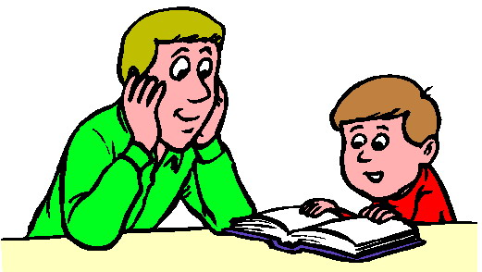
Sharing Reading Time

Dear Parents,
Reading stories to your children is a most valuable activity. When children listen to adults read, it helps them develop an appreciation for written material and for the ideas and thoughts that books can convey. Many experts in the field of reading have determined that parents who read to their children on a regular basis are more likely to have children who are good readers.
Reading aloud is perhaps the most important ways you can guide your child towards reading success. You can open up whole new worlds of adventure and mystery that cannot be found anywhere else, including TV! Children who have been read to will be eager to read for themselves, and will find pleasure in books. Here are some ideas on reading with your child.
- Give your child plenty of opportunities to choose the reading material you read together. Let them pick books based on special interests or hobbies.
- Read aloud with expression. You may wish to take on the role of one of the characters in the book and adjust your voice accordingly.
- As you read an old familiar story to your child, occasionally leave out a word and ask your child to supply the missing word.
- Every once in a while, do some shared reading. You read one paragraph and your child reads one paragraph to you.
- Make reading a regular part of your family activities. Take books along on family outings or trips.
Reading Tip of the Week: After you and your child have finished reading a book together, encourage your child to draw new illustrations on separate sheets of paper. They may wish to include family members in the drawing in place of the regular characters. Use these illustrations the next time your read the actual book with your child. Older children may wish to locate illustrations from different books, and develop a brand new story that can be written and read.

Sincerely,

Mrs. White

