Tiger Times November 2018
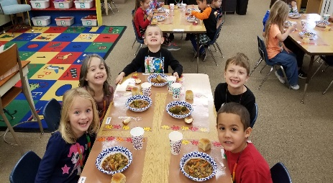
Kindergarten - This month in Kindergarten, we started learning about the seasons in science. We learned all the things that make fall a special season. To celebrate the end of our fall unit, we had a Harvest Feast. We read the book Growing Vegetable Soup and students bought in vegetables that we made into a vegetable soup. Mrs. Rauth
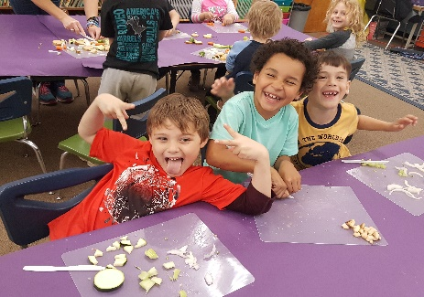
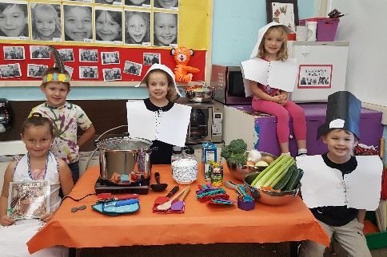
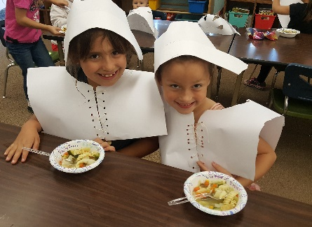
1st Grade - Canyonville first graders have been very busy with many phonemic awareness activities. We completed addition and subtraction units in math. We wrote letters to Veterans thanking them for their service. The kids made stone soup on our new induction cooktop purchased through the CCCU Chalkboard Grant. We will end the month with a flashlight lunch for all the kids who made their homework goal. Mrs. Cullett

2nd Grade The Second Grade at Canyonville spent the month of November completely immersed in our Core Curriculum. In Reading, we learned about the Characters/Settings/Main Ideas/Details in a story. Our Math lessons have included addition and subtraction within 1000, Place Value within the thousands place, and Ordering Numbers. We have used Circle Charts to organize our thoughts to write stories about our Families, and Thanksgiving (What am I thankful for?). Despite being unbelievably busy, we also found time to take part in some November events (Veteran’s Day, Thanksgiving). We are looking forward to all the exciting happenings coming up in December! Mrs. Harbaugh

3rd Grade In third grade, we have started to read texts that are more informative. We are spending a lot of time using text evidence to back up our statements during discussions. We are also getting into informative writing and students are enjoying getting to research ideas that interest them. We will continue working on informative reading and writing through December and into the first part of the New Year. We have just finished our first chapter on multiplication and have introduced division. Students are excited to learn two new math operations in third grade! Mrs. White

4th Grade In reading we are learning different skills and strategies as well as test taking skills. In math, we are learning long division. The students are starting to feel comfortable with this. We are starting our first reports and writing. It will be writing a report about a president. For Thanksgiving, our class made a vegetable beef stew, salad, and bread. That class had a good time celebrating with our peace and learning about Thanksgiving. Mrs. Mainz
Fifth grade is working hard. We continue to work on reading smoothly with expression and good comprehension. Being able to write in the “Close Reader” has been super valuable as we learn to recognize, identify and use patterns and parts of language such as: conjunctions, prepositions and phrases. Our lessons have been integrating ecosystems, food chains vs. food webs, communities, and habitats with writing super sentences and because/but/so sentences. The students are working their way through the fifth grade spelling words and hoping to be well prepared for the spelling bee. We have been working on math skills from place value to decimals and are well on track for memorizing the basic multiplication and division facts. Finally, we have scheduled and are looking forward to a spring Crater Lake field trip to learn about observations, measurements, and that particular habitat. This is a great group of students. Mrs. Beasley

PE - K-2 have been learning step, point throw ( over hand, and underhand throwing) Some examples of fun activities they have learned are burst the bubble, ocean rescue, the rain drop game, and ants in the pants.
3-5 have been working on soccer skills. Dribbling, trapping, passing, kicking, goal shooting, offense defense, and game play. Some example of the activities students have worked on in class are sharks and minnows soccer style (offense and defense), Mass soccer (mini game play), 1 on 1, 2 on 2, 3 on 3, shooting on goal, and soccer skill stations.
6- 8 have been working on soccer. We started with the basic skills of dribbling, trapping, passing, ball control, offense and defense. The skills all lead up to a soccer tournament where each team has to play each other using the skills they learned through the unit. Middle school also does workout Wednesdays. Each Wednesday the students are divided into groups and rotate from station to station which has a different exercise. There are eight stations and each station is 3 minutes long. Some examples of the exercises are burpees, lunges, squats, step-ups, different variations of push-ups, leg raises, sit-ups, triceps dips, inchworm, jumping jacks, jump rope, wall sits, etc. Ms. Mohler/Mrs. Lowry

English - My performance task class is extra support for both reading and math in preparation for the standardized tests given throughout the year. The extra math support is for three days a week and the extra reading support is for the other two days a week. For math, we have been working through a unit on probability, more specifically, focusing on the probability of simple events, and using manipulatives to reinforce those new concepts. For reading, we have been working through a series of non-fiction and literary articles from ReadWorks, a research-based program designed to help support reading comprehension intervention.
My ELA 6th graders have worked through a series of informative texts and activities based on their unit theme, Wonders of the World. They have also read a non-fiction article titled “How to Save the Taj Mahal,” and then answered close reading questions about it. My ELA 7th graders have worked through a series of informative texts and activities based on their unit theme, Nature’s Fury. They have also had a creative writing assignment and academic vocabulary. My ELA 8th graders have started a unit on survival. They have learned about the skills needed to survive on a deserted island, researched what they would be surrounded by on that island, and written out their theoretical survival plans step-by-step. They have also read a short story by Jack London titled “The Story of Keesh,” and then answered close reading questions about it. All three ELA grades have had daily, explicit vocabulary instruction as well. Mrs. Lowry

Math 1/Pre Alg/6 SS Math I— The sixth grade math class continues its focus on the rational number system. Most recently the students are employing their knowledge of rational numbers to solve problems involving finding some percent of a number.

Pre-Algebra—This class has been solving multi-step equations. We are now working with more complex equations with variables on both sides of the equation and include rational coefficients. These are foundational skills for our next focus—linear equations. Linear equations have many applications in life. One common application is when dealing with variables rates in financial matters.

Social Studies 6— The sixth grade class has been introduced to GRAPES—a method for approaching social studies which looks at how geography, religion, achievements, politics, economics, and social structure influence a society. Now the class will begin using this framework to examine the foundations of early civilizations. Mr. Jenks
SS 7. SS7- In seventh grade social studies we just finished reports on Nobel Prize winners and analyzed what their achievements have done for mankind. We are moving on to the concept of economics. We are studying how the three economic systems (traditional, market and command) determine the use of scarce resources in a society.
SS 8 - - In eight grade social studies we are finishing a unit on the Articles of Confederation and the outcome on the Constitutional Convention. From here were will be looking at the Goals (Preamble) and the Fundamental Principles of the US Constitution that are country was founded on, some of which include popular sovereignty, separation of powers and federalism. Mrs. Pennington

Middle School Science:
8th grade: These students are learning about motion and forces. They are learning to record accurate data, how to compare data, when and why to question data, and then they graph position, time and speed. Students use photo gates and tracks with cars to manipulate variables set by the teacher or they set their own.

7th grade: These students have learned the intricate parts of both animal and plant cells. Students have used microscopes to compare and contrast animal and plant cells.

6th grade: These students have been studying the Earth’s interior, how the continents may have “drifted” to where they are now, and why scientists need evidence in order to make accurate hypotheses. Mrs. Boye

Leadership:
Not only does this class do their best four times a week to help keep the school clean, they also take turns serving breakfast daily, they also planned a very successful Halloween dance and had a candy drive to support local businesses that support our school. Mrs. Boye

Attendance Matters
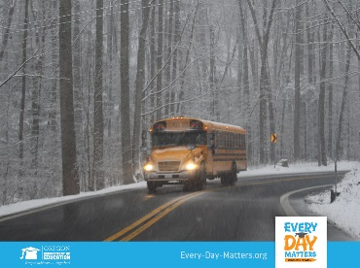
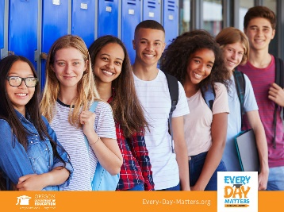
Did you know there is a close connection between school attendance and high school graduation? If you or someone you know is experiencing challenges that interfere with school attendance, our community has many ways to help. From housing and transportation challenges, to emotional kids who simply do not want to go to school, we can help troubleshoot. Visit Every-Day-Matters.org to learn more. #EveryDayMatters #Attendance

Brrr! Winter weather is just around the corner. Be prepared for those days when the roads are too slick for you to venture out. If buses can run safely, they will. If your child rides the bus, check the school district website for snow routes and status. #EveryDayMatters #Attendance

October Kind Tiger and Student of the Month

October Inspirational Tigers
K – Emilio Jaco-Banegas
1 – Matthew Gonzales
2 – Elianna Freeman
3 – Ella Blansett
4 – Evan Snook
5 – Danika Richardson
Middle School Student of the Month
6 – Savana Ordner
7 – Lorena Hernandez
8 – Drayk Barrong

The Canyonville girls’ basketball team is 3-2 in conference. Both losses have been to the number one team in the conference by a combined score of 5pts. If the girls stay on track, they will make it to the league championship on Saturday, December 8, 2018 in Days Creek. Coach Graziano has the girls playing aggressively and with passion.

Canyonville Happenings

We are beginning elementary music for the next 12 weeks. The music teacher is Megan Hamontree and she currently is the Canyonville Band Teacher. For the next four weeks, Ms. Hamontree will have the students singing holiday songs culminating in a Holiday Assembly Wednesday, December 19, 2018 in the Canyonville Gym at 6:00 p.m.
Music Schedule
Monday – Tuesday and Thursday – Friday
Time | Location/Class
9:00 - 9:35 | 2nd Grade – Harbaugh
9:35 – 10:20 | Assist with K-2 or Middle School
10:25 – 11:00 | 5th Grade
11:00 – 11:30 | Prep
11:35 – 12:05 | 1st Grade
12:10 – 12:50 | Lunch
12:50 – 1:25 | Kindergarten
1:30 – 2:05 | 4th Grade
2:05 – 2:40 | 3rd Grade
2:40 – 3:30 | Middle School Band

