Tiger Times January 2019
Our boys basketball athletes have worked hard to become eligible to play. We currently stand 3-4 with one remaining game on Monday, February 4th, against Glendale. The boys are determined to come away with the win and change Glendale’s 7 – 0 standing. Wish us luck!

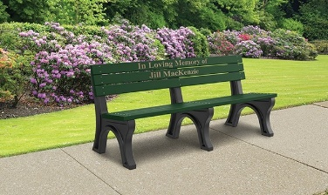
On January 19th, in our Canyonville Gym, we paid our respect to one special lady, Roxy Slater. Roxy passed away unexpectedly on January 7th. Roxy was an employee of the South Umpqua School District for thirty years. She loved Canyonville School, the staff, and of course, the kids! We lost a co-worker and very special friend. Kathy Brown and Shari Lydick have spearheaded a project to place a memorial bench, in honor of Roxy, at Canyonville School. Donations will make this project possible. Thank you to those of you that have already donated.
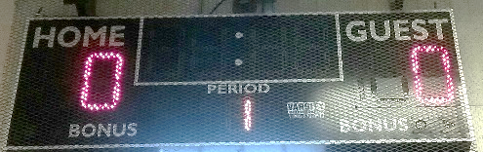
We would like to once again thank the Canyonville South Umpqua Fire Department and the Canyonville South Umpqua Fire Board for donating the funds to purchase our new score board. The scoreboard was installed and is ready for its debut on February 4th. We appreciate your continued support!!!

Kindergarten
This is such a fun time in Kindergarten. My students are now able to read early-leveled storybooks. They are so excited to be readers! They are writing their first stories that will be a published book. They love being authors and illustrators.
Our science unit this month was weather. We learned the different kinds of weather. We talked about now the weather changes in each season. In math, we made a graph of our daily weather for the month.
Mrs. Rauth

1st Grade
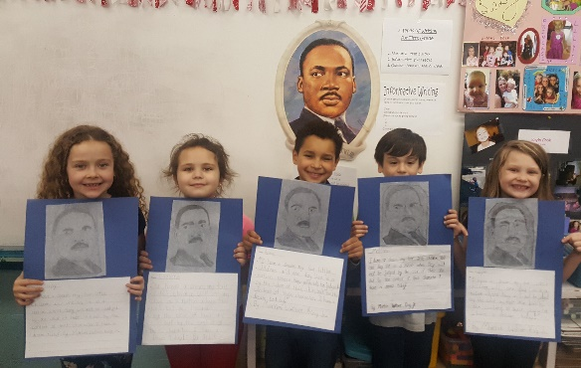
Canyonville First Graders learned about Martin Luther King Jr. The kids recited his “I Have a Dream” speech and made a sketch of him. We are writing informative books while learning about six types of penguins. Our first book was all about the Rockhopper Penguins. Our second book will be about King Penguins. We have read, learned and compared the two types of penguins. We look forward to writing and illustrating our next book. We are also learning about place value and long vowel sounds. Mrs. Cullett & Kids 😊
2nd Grade
The Second Grade students at Canyonville spent the month of January learning our objectives in all Curriculum areas and winter term FAST testing in aReading, aMath, and CBMR. FAST testing requires a great deal of time and effort on everyone’s part and I am pleased to report that we have seen an exceptional “Go-Up-Ness” in scores from the fall term. These kids seriously “rock my world” and I am quite proud of them all.
Mrs. Harbaugh

3rd Grade
Third grade is working on informative paragraph writing. In reading, we have worked on drawing conclusions, making inferences, text features and domain specific vocabulary. In math, we have started working on identifying whole fractions and fractions in a set. We will start working on equivalent fractions next week. We continue to work on CAT and PT SBAC practice.
4th Grade
In reading, we have been reading a mix of fiction and nonfiction text. Students also completed their second performance task. Students were to read three different sources over the same topic. They took detailed notes and used those notes to answer questions and write a four to five paragraph paper.
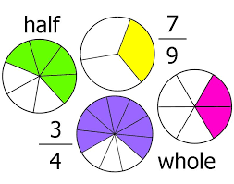
The students are finishing their informative writing unit. Students have been writing about several different topics. They have completed papers about presidents, animal adaptions, and an important person in their lives.
The class is still working on fractions. This has been a tough math unit, but the students are doing great. We have learned to compare and reduce fractions as well as convert mixed numbers to improper fractions. The students are learning to build fractions using models and number lines as well as the traditional methods.
We finished our Fast Bridge Assessments and we are currently reviewing the data to update our reading intervention groups. Mrs. Mainz
5th Grade
5th grade has been working our way through the math skills. It was delightful the other day to hear students say, “This is fun!” while drawing models for multiplying fractions by fractions and practicing the steps for fraction multiplication. We have been enjoying the different types of figurative language. The class favorite has been irony! In our anthology, we have been reading about the American Revolution. It is great that we can improve our reading skills while learning about our country. Discussions about the differences between tornado and hurricane have been very engaging and writing from our multi-paragraph outlines is becoming more comfortable. Ms. Beasley is learning too. The students have been helping her learn to use the procedure for CHAMPS with more confidence. Planning for field trips and testing have been on our minds. We will be walking to the Acclamation Pond for the Steelhead release, snowshoe hiking at Crater Lake and learning about marine life in Newport. We will also have fun with graphs, fractions, percentages, etc. as we open our boxes of conversation hearts this month. Thank you for all that you do to make these things possible
P.E.
K-5th grades have been working on their jump rope skills. Students began learning
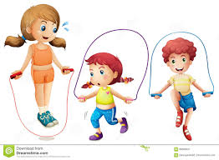
different jump rope skills like single jump, double jump, jump and turn, double jump and turn, skier, bell, crisscross, and one-foot jump. They started practicing these skills with their jump rope "snake" on the ground. That way, students got comfortable with their foot placement and having the feet leave the ground. Once students where comfortable with that, we picked up the jump rope and learned forward and backward arm circles and learned the progression of how to swing/move the jump rope in order to jump it. Students were able to work on their different jump rope skills during stations while listening to music in physical education class.

The 3rd - 5th grade students continue to improve on their banner run each week in class. During the month of January the students worked hard and tried their best at running January's banner run for 5 ½ minutes.

Middle school PE classes have been working on floor hockey. Students worked on hockey skills such as puck handling, stick handling, individual drills, group drills, passing, blocking, offense, defense, goalie, teamwork, and game/tournament play. Middle school continues to have a workout Wednesday where each Wednesday student are in groups and rotate around to different fitness stations to improve their personal fitness.
Mrs. Mohler

Middle School Science
It is the end of the semester in middle school. Science classes have been wrapping up various units. Sixth graders have finished a weather unit, seventh graders should know all about cell division and the eighth graders designed three step devices that pop a balloon! Mrs. Boye’
Leadership
The middle school leadership class has continued to try to spread positive energy with quotes, locker notes, and helping to plan a Valentine’s dance for February 8th.
Mrs. Boye’
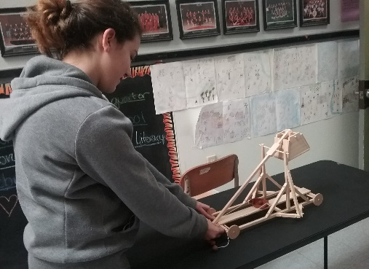
Social Studies 7- In seventh grade we are studying the Middle Ages. We just finished an assessment on feudalism and we are starting a unit on castles and siege weapons. Students were able to see and practice firing a model trebuchet purchased with funds from the SUSF. In the upcoming weeks, we will build castles and our own model weapons.
Social Studies 8- We are currently working in a unit surrounding the three Branches of US Government. In addition to the requirements and powers, students are given an opportunity to research and form opinions about many of the current issues presented in the media (Congressional term limits, the Electoral College and Supreme Court decisions). It was exciting that a few students were able to attend the town hall meeting with Senator Merkley. Mrs. Pennington

Math I
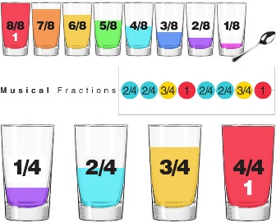
The sixth grade math class has recently finished a unit on multiplying and dividing fractions and mixed numbers. We have just started into a new unit on ratios. Students will learn to use the language of ratios as they compare quantities of one item to another. This will be an opportunity for students to deepen their understanding of proportionality and equivalence. This unit will also involve finding unit rates. Concepts such as miles per gallon (mpg) will begin to make much more sense to students.
Pre-Algebra
Recently, the pre-algebra students have been applying their skills of graphing linear equations in order to solve systems of equations graphically. The class is preparing to use the algebra skills they have acquired to solve these systems through algebraic methods. The data generated by solving systems of equations often guides business and economic decisions. Upon successful completion of this unit, students will have honed their skills of algebraic manipulation and equation solving.
Social Studies 6
The sixth graders are learning about the beginnings of civilization in the Mesoamerican region. Some of the key things they are learning is how the Olmec people were able to farm the land on which they settled and how Olmec civilization influenced the following Mesoamerican civilizations—now students are beginning to understand what is meant when the Olmec culture is referred to as the mother culture.
Mr. Jenks
English

For Performance Task, we have been continuing our work through fiction and non-fiction articles from ReadWorks. We have also wrapped up our unit on Probability, finishing with the Fundamental Counting Principle and Independent and Dependent Events. We ended the class with a summative assessment on Probability.
ELA 6th graders have started a novel unit on Wonder by R.J. Palacio. To set the context, we did a pre-reading writing assignment on feeling unique or different. They are about halfway through the novel now and have done comprehension and analysis questions, writing assignments, and a variety of character studies. We have also had plenty of rich, higher-order thinking classroom discussions.
ELA 7th graders have started a novel unit on Inkheart by Cornelia Funke. To set the context, we learned about the fantasy genre and its purpose. We are about a quarter of the way through the novel now and have done comprehension and analysis questions, and a text-evidence based writing assignment. We have also had plenty of rich, higher-order thinking classroom discussions.
ELA 8th graders have started a novel unit on Endangered by Eliot Schrefer. To set the context, we learned about the history and culture of the Democratic Republic of Congo and its surrounding African countries. We are about halfway through the novel and have done comprehension and analysis questions. We have also had plenty of rich, higher-order thinking classroom discussions. All three grades have continued to prepare for the SBAC and have daily explicit instruction on academic vocabulary.
Sarah Lowry

Attendance Works

I hope you and your family are settled in after the holidays. This is the time of year when winter takes a toll on school attendance. Snow and slushy weather can keep parents from getting their children to school. So can the colds, fevers and earaches that often come with the winter months.
These absences, even if they are excused, can add up to academic trouble. If it is a snowy or rainy day but school is still open, students miss out on learning if they aren’t in class. These absences can result in lower test scores and grades.
There’s not much we can do about the weather, but there are two key steps every family can take to help avoid absences this year.
- Develop back up plans for getting your children to school in winter weather. That could mean checking with other families who have a car that can manage in the snow or forming a “walking school bus” to walk your children to school with other parents. If you’re stuck, call the school. We can connect you with other parents or staff members who can help.
- Keep your children healthy. Dress them warmly for the cold weather and make sure they’ve got hats and gloves. Encourage them to wash their hands regularly, and send them to school with a bottle of hand sanitizer.
Above all, let us know how we can help. We want your children and all our students to succeed. And that means attending school every day possible

