Tiger Times February 2019



Principal Park,

I want to personally congratulate your school on the super successful book fair this spring! **Your Book Fair Coordinator, Kristina, worked tirelessly to make this book fair a success! (yes she did!)**

I always tell the Book Fair leaders that they should never forget the impact of the book fair!  Every child that leaves the fair with a book is one step closer to becoming a lifelong reader!!

Check out the two amazing numbers below to see approximately how many books you sold and how many independent reading minutes that creates for your school!

**Canyonville Elementary School**

Spring 2019 book fair results:

**Books Sold:**    313

**Reading Minutes:** 56,337

cid:image002.jpg@01D4CF73.9526BE80

As you can see above our Librarian, Kristina Gale does a wonderful job, choosing a theme, decorating, setting up, and running the Book Fair. Kristina sets a fundraising goal every year and on the last day during the last minutes of the book fair, she met her goal. Thank You, Kristina! We would also like to thank students, staff, parents, and volunteers who made this year’s book fair a success.

In conjuction with the Book Fair Canyonville School had a Title 1 family reading night in the gym.  It was the culminating activity for grades K-5 after reading the book The Year of Billy Miller.   Dinner was served free of charge, cookies were decorated and there were many games and prizes. Information on Title 1 was made available to all families. Many families showed up to help celebrate and make this a great evening.

­­­­­­­­­­___________________________________________________________________

**Leadership**

Love was in the air as the students danced the night away at our Valentines Dance. It is always neat seeing the girls and guys dress up for this special evening. We held the dance in the Community Center, which made for a cozy atmosphere for the dance as opposed to the gym.

**Honor Roll**

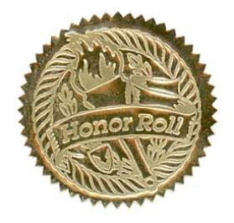We had our honor roll reward lunch for middle school students who made 3.50 or higher for the 2nd quarter. The students ate pizza and received a certificate for outstanding achievement. They went to Diamond Lake to the inner tube hill for a celebration of their achievement. Overall 51% of the middle school students earned a 3.0 GPA and above students.

**Community Center**

The Community Center is a popular place. The Community Center is rented almost every weekend. Most of the rentals are for birthday parties, bridal showers, and baby showers. It is a very nice place to rent and it is a good deal at $50.00 a day.

**Track**

Holy Cow can you believe it is time for spring sports already? We have begun conditioning for the track season and soon as the track is dragged and prepped, we will begin using the track.

**PE/Health**

K-2 has been working on a basketball unit. We have covered and practiced ball handling (making circles around our feet with the ball, figure eights, tap, and switch, etc.) and dribbling with our dominate (the hand we write with) and non-dominate hands.

3rd-5th has been working on a hockey unit. We have covered the different parts of the hockey stick, stick handling, puck handling, and passing so far.  Students are continuing to work hard and improve on their banner runs.

Middle School has been working on badminton hand-eye coordination, clears, and serving so far. 7th and 8th grade have started health this last month and we have covered making healthy choices, social norms, and communication so far.

**Kindergarten**

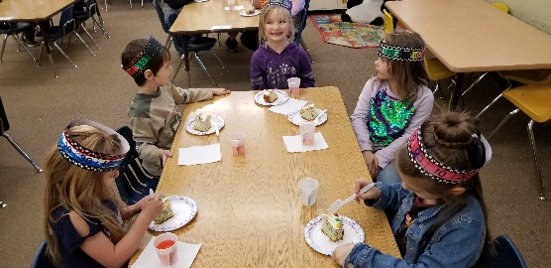There have been 100 days of kindergarten! We celebrated by counting 100 items, reading 100 words, making 100-day headbands and listening to stories about 100. Students who can count to 100 by 1s, 5s and 10s won prizes. We finished the day by eating a cake with 100 candies on it. Yum!

**1st Grade**

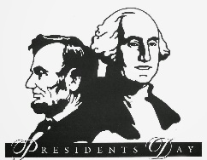February was a short yet busy month. Our school had a Book Fair and Family Night. The kids learned about Phil from Punxsutawney, George Washington, Abe Lincoln, and celebrated Valentine’s Day with the gift of giving cards. We learned about long vowels sounds, place value, wrote an informative book about King Penguins and then we had a “Snow Week”.

**2nd Grade**

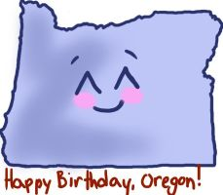The Second Grade students at Canyonville certainly enjoyed all of the activities that the month of February brought ……. In addition to being immersed in our Core Curriculum in Reading, Math, and Writing, we also found time to study the lives of Presidents George Washington and Abraham Lincoln.  We learned about their early lives and how important these men are in the history of our country.  On February 14, we celebrated Oregon’s 160th birthday with birthday cake and punch.  Our Oregon lessons became a favorite part of our day as we became aware of all the awesome things about our state.  I am so pleased with their progress in all areas.

**3rd Grade**

Third grade is currently working on story structure and preparing for smarter balanced testing. Students have shown tremendous growth in math and have recently completed their math unit on fractions. They worked on identifying, comparing, and finding equivalent fractions. We have also enjoyed our trimester of music.

**4th Grade**

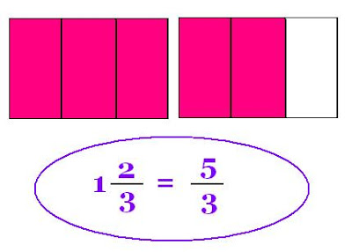We have been covering a lot of topics and subjects in 4th grade. In reading, we have been focusing on skills and strategies such as drawing conclusions, text structure, and main idea and details. Students are now expected to use text evidence when answering questions. We have been digging deeper into the online component of Journeys. Our class has been flying through math. We have finished our fractions unit and we will be moving on to decimals. We have been incorporating different strategies from Shannon McCaw. The students have enjoyed all of the different math activities from Shannon McCaw's training. The class is still working on opinion pieces in writing. We have been working on organizing our thoughts and facts by using different note taking strategies from the writing training with Yolanda Westerberg. Overall, the students have been working hard and keeping a positive attitude.

**5th Grade**

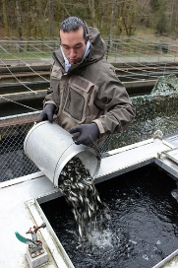In 5th it feels like the year is flying by.  We continue to learn new things and further develop our skills.  We are starting to review, do test practice, and improve our understanding of performance tasks.  We are looking forward to our field trips to learn more about fish, habitats, ecosystems, forests, animal adaptations and much more.  We will soon be working on science projects, demonstrations, and experiments.  Integrating writing into other subjects has helped us get the most out of our classroom minutes.  We are seeing the fruits of our labors as we assess and conference, teacher to student.  This is a very curious and motived group of scholars.  It is exciting to watch them learn and grow.

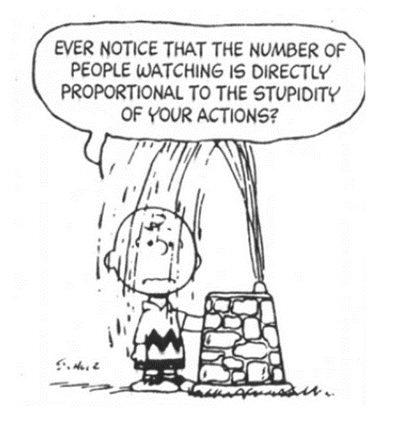**All of Canyonville’s math classes are looking forward to celebrating Pi Day need week on March 14. (3.14)**

**Math 2** is currently working on determining whether a situation is proportional. They are doing this in multiple forms, tables, graphs and direct variations (equations). They are building on the concept of rate and slope, which will be a reoccurring concept in future math endeavors.

**Mod. Math** is finishing a unit on solving proportions using cross multiplication. They are also applying this to find the missing side lengths of geometric figures.

**Algebra 1** students are being introduced to polynomial expressions. They are learning how to multiple binomials using the process of FOIL (first outer inner last). As well as looking at factoring polynomials which will lead to the quadratic equation.

**Math I**

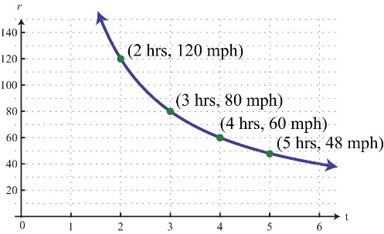The sixth grade math class has been working with ratios and rates. Students are learning to use the language of ratios as they compare quantities of one item to another. This course of study has provided the opportunity for students to deepen their understanding of proportionality and equivalence. As students are finding unit rates, concepts such as miles per gallon (mpg) are beginning to make much more sense to students.

**Pre-Algebra**

After learning to solve systems of linear equations graphically, the class learned to use their acquired algebraic skills to solve these systems through algebraic methods. The data generated by solving systems of equations often guides business and economic decisions. As we are nearing the completion of this unit, students have honed their skills of algebraic manipulation and equation solving.

The Pre-Algebra students will soon be moving on to learn what a function is and the distinction between a function and a relation. This will expose the class to non-linear functions and relations.

**Social Studies 6**

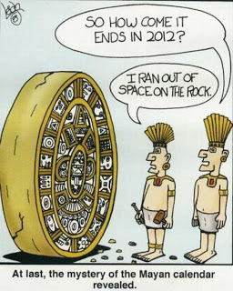The sixth graders are learning how a society’s beliefs can permeate all aspects of that society—even evidenced through the society’s achievements. For example, the Mayan civilization is the latest civilization the sixth grade has been studying. They have seen how the Mayan base 20 number system was incorporated into their calendars, which contained 20 days per month. The Mayan’s 365-day calendar had 18 months with 20 days. This left 5 extra days at the end of the

**English**

For Health, the 6th graders have worked through a series of lessons introducing emotional, social, and physical wellness, and have completed a unit on health behavior and setting personal goals. This week begins the second unit on emotions and behaviors, covering topics such as self-esteem, self-image, and dealing with emotions.

 For Writing, the 7th and 8th-grade mix have started an argumentative writing unit, working their way through the writing process. So far, we have covered the components of an argumentative essay, chose topics, researched and brainstormed those topics, wrote the first draft step-by-step utilizing a variety of graphic organizers, and are now typing the first draft.

    ELA 6, 7, and 8 have continued their novel unit studies on *Wonder* (6), *Inkheart* (7), and *Endangered* (8). We have done lessons on fictional elements such as setting, and have continued analyzing the characters. We have also answered comprehension analysis questions and have had daily classroom discussions. All three ELA grades have continued to prepare for the SBAC, had daily explicit instruction on academic vocabulary, and have had mini-lessons on both nouns and verbs.

**Science**

Middle school science has been very busy!

Physical science students have been studying the periodic table.  The students have been learning about the symbol, history of the periodic table, as well as how elements are used everyday, all around us.

Life science students learned about Gregor Mendel, the father of genetics.  They can complete Punnett Squares and tell you about how and why traits determine what people look like.

Earth science students have begun to learn about the scientific method.  They have conducted a lab, analyzed data, and have learned to draw conclusions from their data.